Grenoside surgery
Patient participation GROUP MEETING
minutes

hELD ON wEDNESDAY, 30th July 2025
grenoside surgery, conference room
Time: 2 pm

Present:

Chair: Kara Eaves (Practice Manager), Hilary Power (Assistant Manager), Beth Jackson
(Receptionist)
Minutes: HJP

Patients: EW, BL, JB, DW, RN, AG, SC, DS, SB, JP, CG

Discussion
- Total Triage: Controlled by AccRux – the practice has no control over his software
Red – same day appointments
Amber – within 7 days > including booking link*
Green – within 14 days

How to access Telephone Triage
Grenoside Website – front page
↓
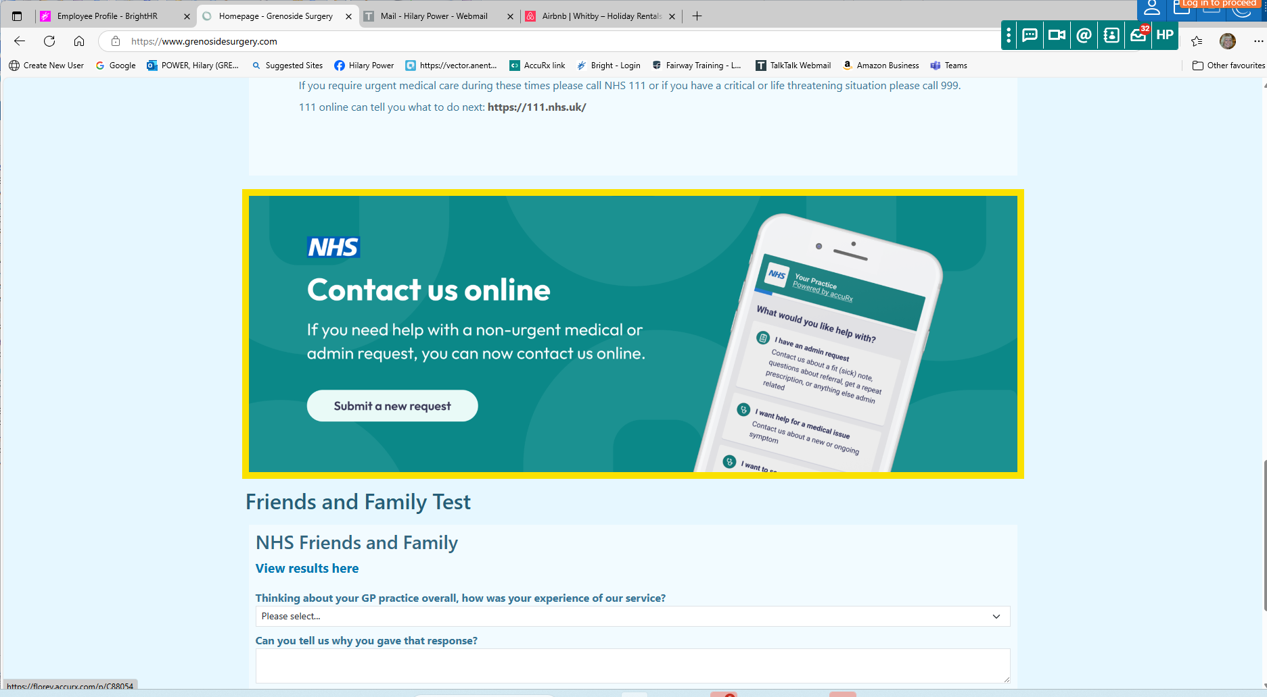
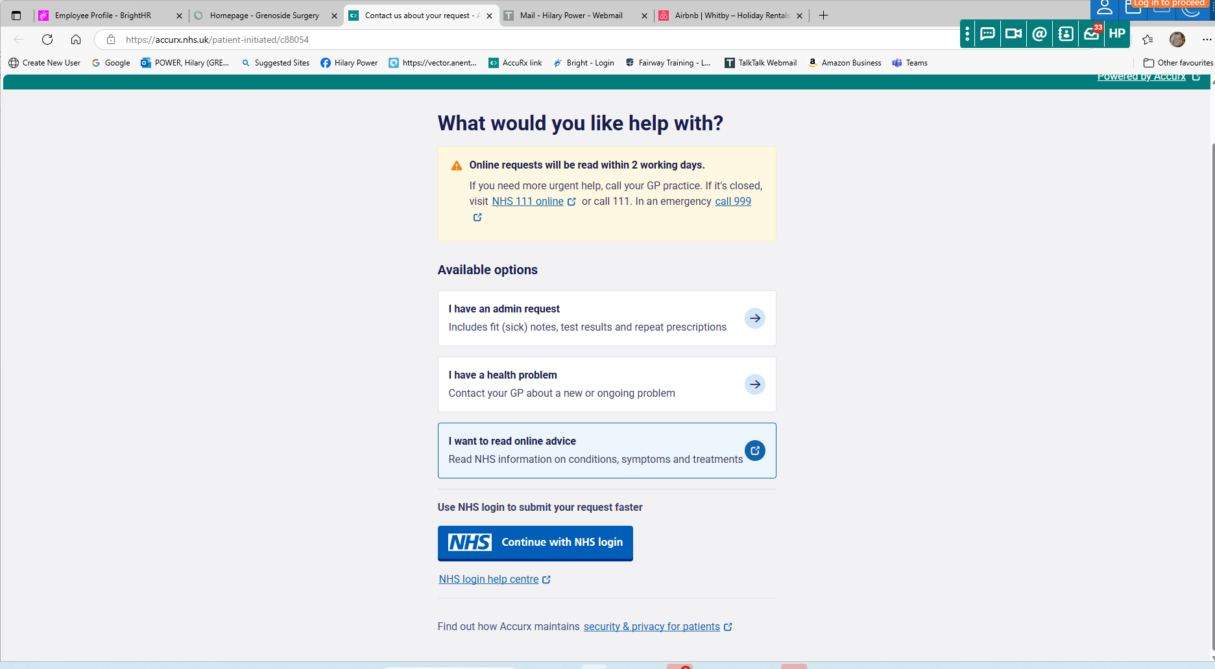
The group commented Total Triage is ‘100% better’. Some felt apprehensive at first in terms of how TT would work for them, but are finding the service much more efficient.
Beth confirmed reception staff are always happy to help patients to complete the form if required.
We went through how to access Total Triage – via NHS App and Grenoside Website (first page – see above). To access via the NHS App – click on ‘services’ (bottom left of screen) then ‘contact your GP about a health problem’
One of the group commented they found the first email forwarded from the practice explaining the new service ‘overwhelming’. We did have an open day for patients to come into the practice to help with accessing and completing the TT form. Following on from this we plan to have another open morning and/or afternoon to help patients with access.
We agreed the booking appointments link on the website was confusing – this has now been updated.
DNA’s (did not attend) appointments are at 10%.
One member of the group confirmed you are able to speak into your mobile phone to complete the triage form and this will automatically type the narrative in. You will need appropriate settings turned on – details are available on the NHS Website.
- Telephones:
Kara and Hilary confirmed we are constantly looking at the telephone options with a view to ensuring this is helpful to patients. Beth commented the ‘ring back’ facility will only be answered when one of the reception staff becomes available. We try to have a minimum of five staff available to answer the telephones, including the admin staff if needed.

- Ear Syringing
We are now starting this service up again. Patients will need to book in for an ear check in the first instance with a nurse prior to booking in for the syringing.
The group asked about if ear syringing is appropriate if patients have a hearing aid*.
PM Note: HJP has checked with our Nurse Practitioner and confirmed patients with a hearing aid can have syringing done in practice.
- Flu season:
We are fast approaching flu season again and plan to have a Saturday Clinic and morning and afternoon appointment slots. Details will be added to the website in due course. Our delivery is due week commencing 15th September.
- AOB
We confirmed all minutes will be added to the website – the website if updated on a regular basis.
Since Dr Shelley Jackson’s departure, Dr Robin Meakin has increased his sessions.
We also regularly have F2 doctors (Foundation Year 2) on a quarterly basis. Our next two F2’s will start on 6th August and will be with us until the beginning of December.
We have also now agreed to have a medical student with us once again – students will be with us periodically on a short placement.
Newsletter – Kara is planning to publish another newsletter in due course.

Date of next meeting: to be arranged.

